|  |  |
| --- | --- |
|  | FPT ACADEMY INTERNATIONAL  FPT – APTECH COMPUTER EDUCATION |

Centre Name: ACE-HCMC-2-FPT.

Address: 590 Cach Mang Thang 8, District 3, Ho Chi Minh City, Viet Nam.

**[Fun Zone]**

|  |  |  |
| --- | --- | --- |
| Supervisor: | Phạm Thị Lánh | |
| Term: | T1.2202.M0 | |
| Group No: | 4 | |
| Order: | Full name | Roll No. |
| 1. | Hoàng Ngọc Hân | Student1368162 |
| 2. | Nguyễn Thế Dương | Student1368168 |
| 3. | Vũ Đức Châu Anh | Student1368157 |

Month 05 Year 2022

This is to certify that

**Mr. HOÀNG NGỌC HÂN**

**Mr. NGUYỄN THẾ DƯƠNG**

**Ms. VŨ ĐỨC CHÂU ANH**

Have successfully Designed & Developed

**FUNZONE**

Submitted by: **Ms. PHAM THI LANH**

Date Of Issue: May, 2022

Authorized Signature:

Contents

Acknowledge 4

Synopsis 6

REVIEW 1 7

Problem Statement 8

Customer Requirements Specifications 9

Architecture and Design of the project 10

Site map 11

Screen shots 12

I. Homepage. 12

12

II. Experience 13

III. Leisure & Dinner. 14

IV. Parks Characters. 15

V. Whats up. 16

VI. Park Information. 17

VII. Business Opportunities. 18

VIII. Contact Us. 19

IX. Footer. 20

REVIEW 2 22

I. Homepage 23

II. Experience 24

III. Leisure & Dinner 25

IV. Parks Characters 26

V. Whats up ! 27

VI. Park Information 28

VII. Business Opportunities 29

VIII. Footer 30

Task Sheet 31

Testing document 32

Final checklist 33

# 

# Acknowledge

As we understand that the eProject is a step-by-step learning environment that closely simulates the classroom and Lab based learning environment into actual implementation. It is a project implementation at your fingertips!! An electronic, live juncture on the machine that allows you to.

✓ Practice step by step i.e., laddered approach.

✓ Build a larger, more robust application.

✓ Usage of certain utilities in applications designed by the user.

✓ Single program to unified code leading to a complete application.

✓ Learn implementation of concepts in a phased manner.

✓ Enhance skills and add value.

✓ Work on real life projects.

✓ Give a real-life scenario and help to create applications more complicated and useful.

✓ Mentoring through email support.

We would like to send a great thank to our professor and others student for the adorable support during the time in the project.

Beside several mistakes we had made in the project, we hope to have more opportunities to widen our knowledge in the web developing world.

We also thank you so much for your information and the “demo” project from India APTECH to help us get more reality experience in this project. Since we have gained more experience from this project, we will not stop learning anything as much as we can to be more successful in the future.

Your Sincerely,

Team Group 04.

# 

# Synopsis

- The Objective of this program we aim is to give a sample project to work on real life projects. These applications help us build a larger, more robust application.

- The objective is not to teach us HTML/JavaScript but to provide us with a real life scenario and help us create basic applications using the tools.

- Hence, we can revise the chapters before we start with the project.

- This project The Objective of this program is to give a sample project to work on real life projects. These applications help you build a larger, more robust application.

- The objective is not to teach you the software but to provide you with a real-life scenario and help you create basic applications using the tools.

- You can revise the topics before you start with the project.

- This project is meant for students who have completed the module of HTML5.

- These programs should be done in the Lab sessions with assistance of the faculty if required.

- The website (in this project) is a tool that help the company to access the

international market and gain more and more new customers.

- It is very essential that a student has a clear understanding of the subject.

# 

# REVIEW 1

## Problem Statement

The ‘FUN ZONE’ Most Entertaining Theme Park, is one of the best ideas executed in the amusement &amp; entertainment industry. It caters to everyone, be it a child who seeks entertainment or an adult who wishes for a pleasant evening. This initiative is aimed towards providing its visitors with ample elements to spend a quality day. It promises fun and frolic packed with adventurous and elegant ambience.

It has 7 different internationally themed zones which will keep you occupied for the entire day. You will never fall short of excitement or thrills, thanks to the mascots that will make sure you are treated with the best of hospitality. There are zones like thrill rides, 7 wonders of the world, a massive food court and other areas ensuring 360 degrees of sheer entertainment.

Growing in popularity, the park has connected with thousands of families and has successfully entered the massive amusement &amp; entertainment industry.

‘FUN ZONE’ is looking to have it’s own website to provide information and also connect with prospective clients.

The website is to be developed for the Windows Platform using HTML5, JavaScript and Geolocation. The site should work well in all leading browsers including Chrome,

IE, Firefox etc.

## Customer Requirements Specifications

|  |
| --- |
| USER: |
| Input:  ● Input consumer’s address of residence or office  ● Send questions/requests to the company |
| Process:  ● Process consumer’s address data  ● Collect questions/requests sent by consumers |
| Output:  ● Show the store address to consumers  ● Reply to the consumer’s requests/questions |

|  |
| --- |
| WEBMASTER: |
| Input:  ● Control website database, input product information,… |
| Process:  ● Analyse website |
| Output:  ● Website interface, images, forms, …  ● Giving interaction |

|  |
| --- |
| HARDWARE / SOFTWARE REQUIREMENT: |
| Software:  ● Notepad/HTML editor  ● Dreamweaver/Javascript |
| Hardware:  ● A minimum computer system that will help you access all the tools in the courses is a Pentium 166 or better  ● 64 Megabytes of RAM or better |

## Architecture and Design of the project



## Site map

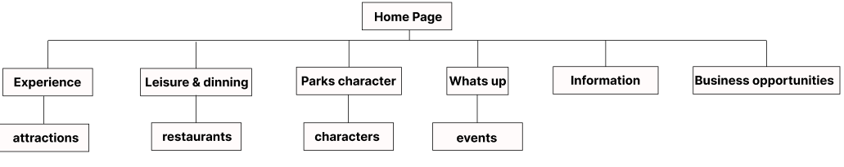

## Screen shots

### Homepage.

### 

**Description:** This is a homepage of FunZone , at the top is the navigation bar then the title. The gentle nature background image helps users feel comfortable when exposed for the first time.

### Experience

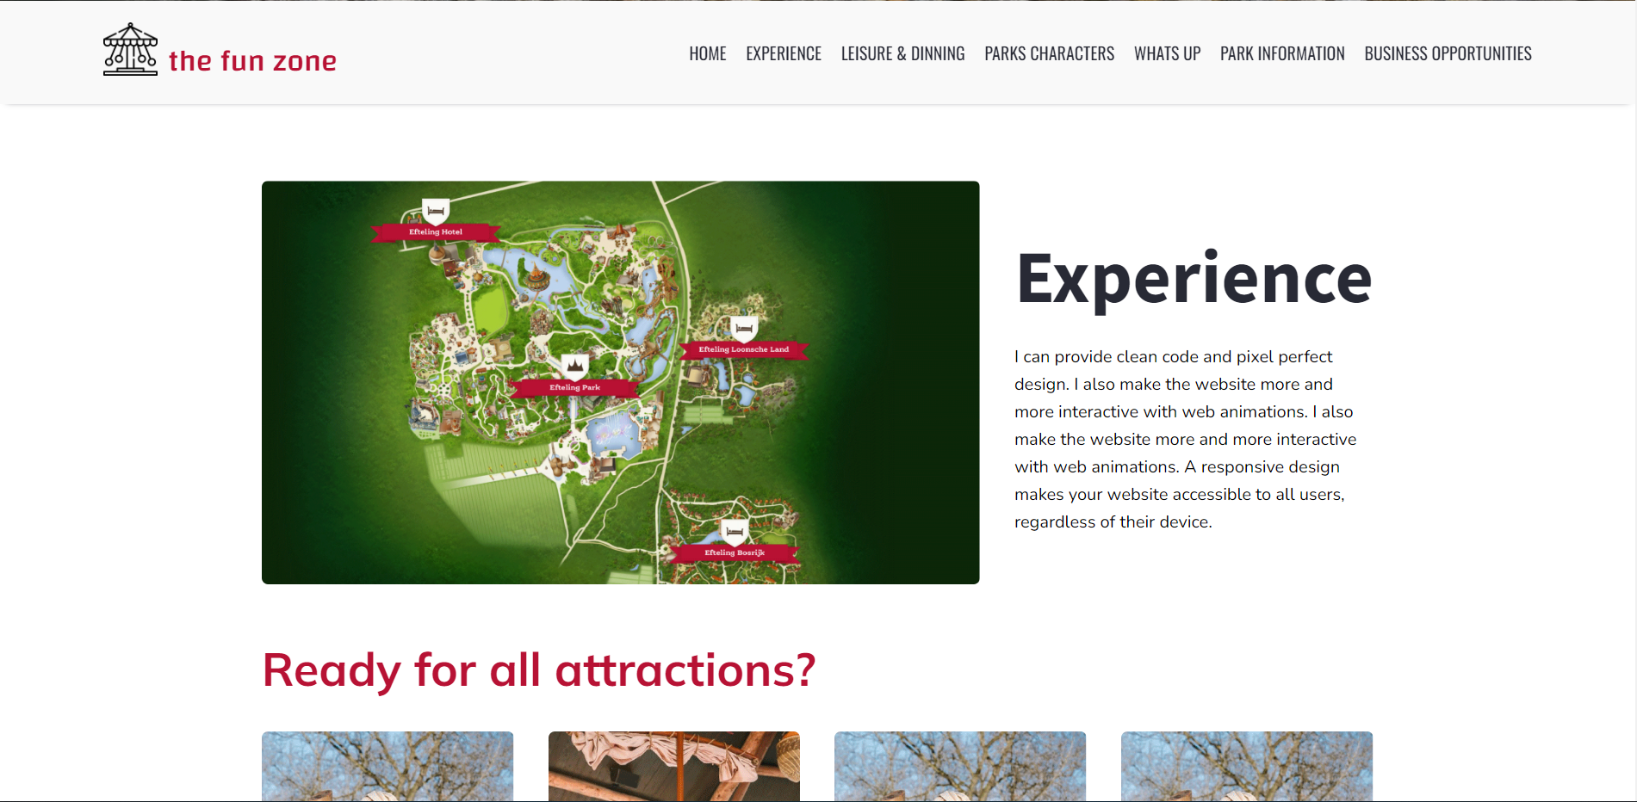 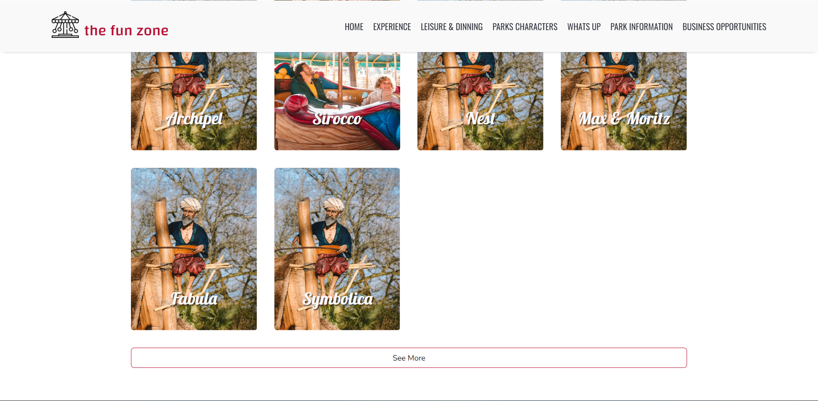

**Description:** The Experience section in the website provides an overview of the experience to be brought and some hints about the experience available to the user.

### Leisure & Dinner.

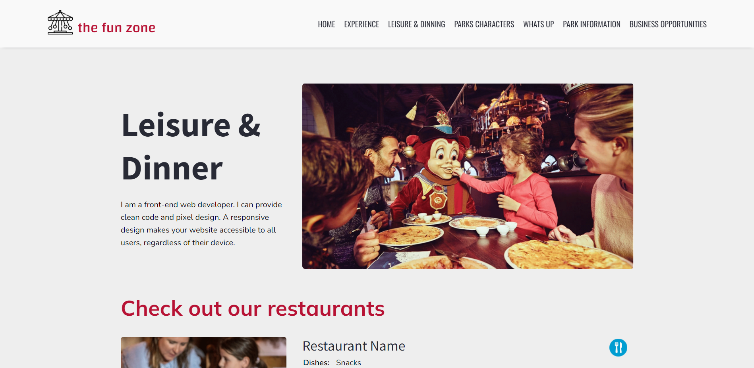 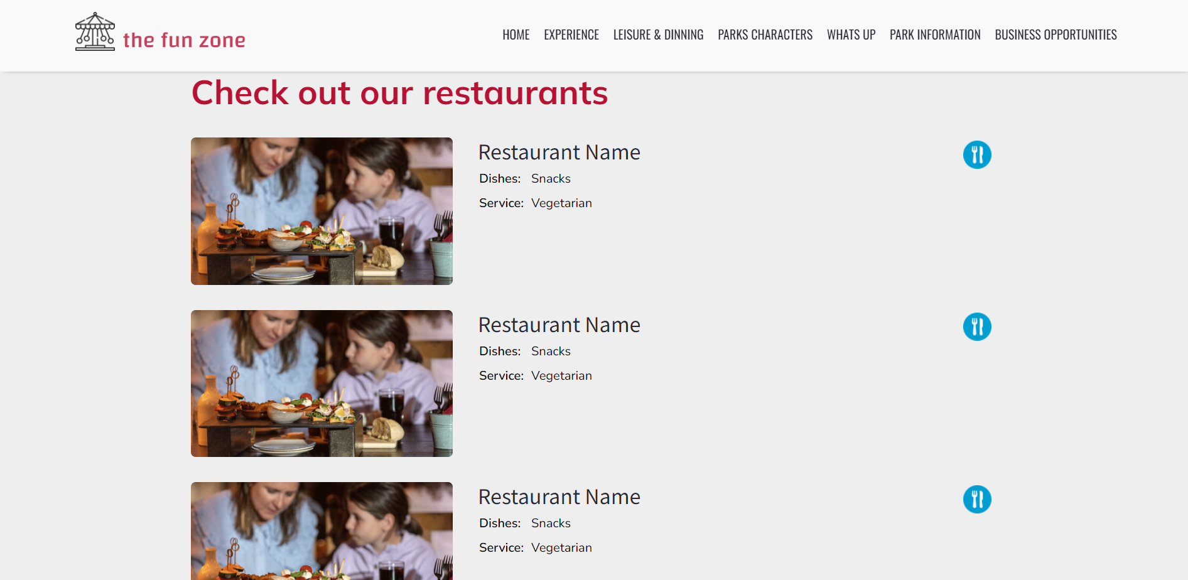

**Description:** In this section, we will introduce entertainment services in our spare time and suggest to users restaurants that match their interests.

### Parks Characters.

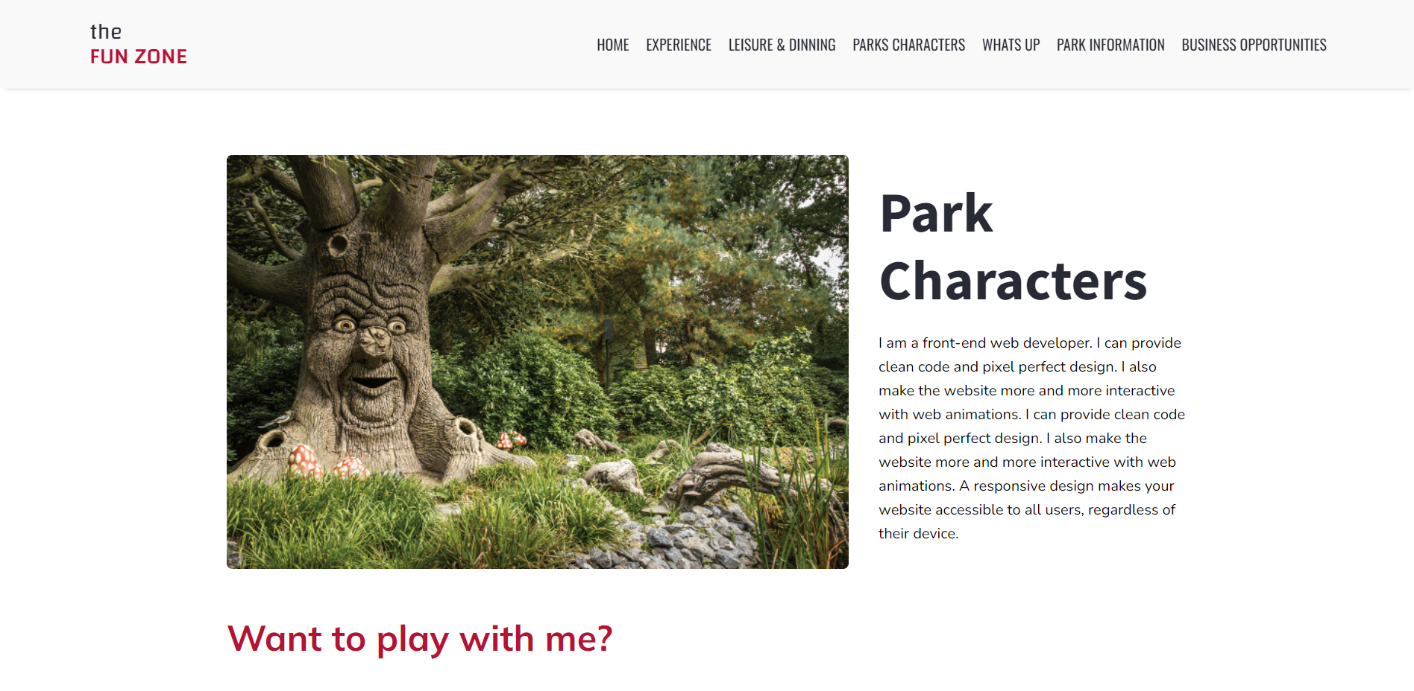 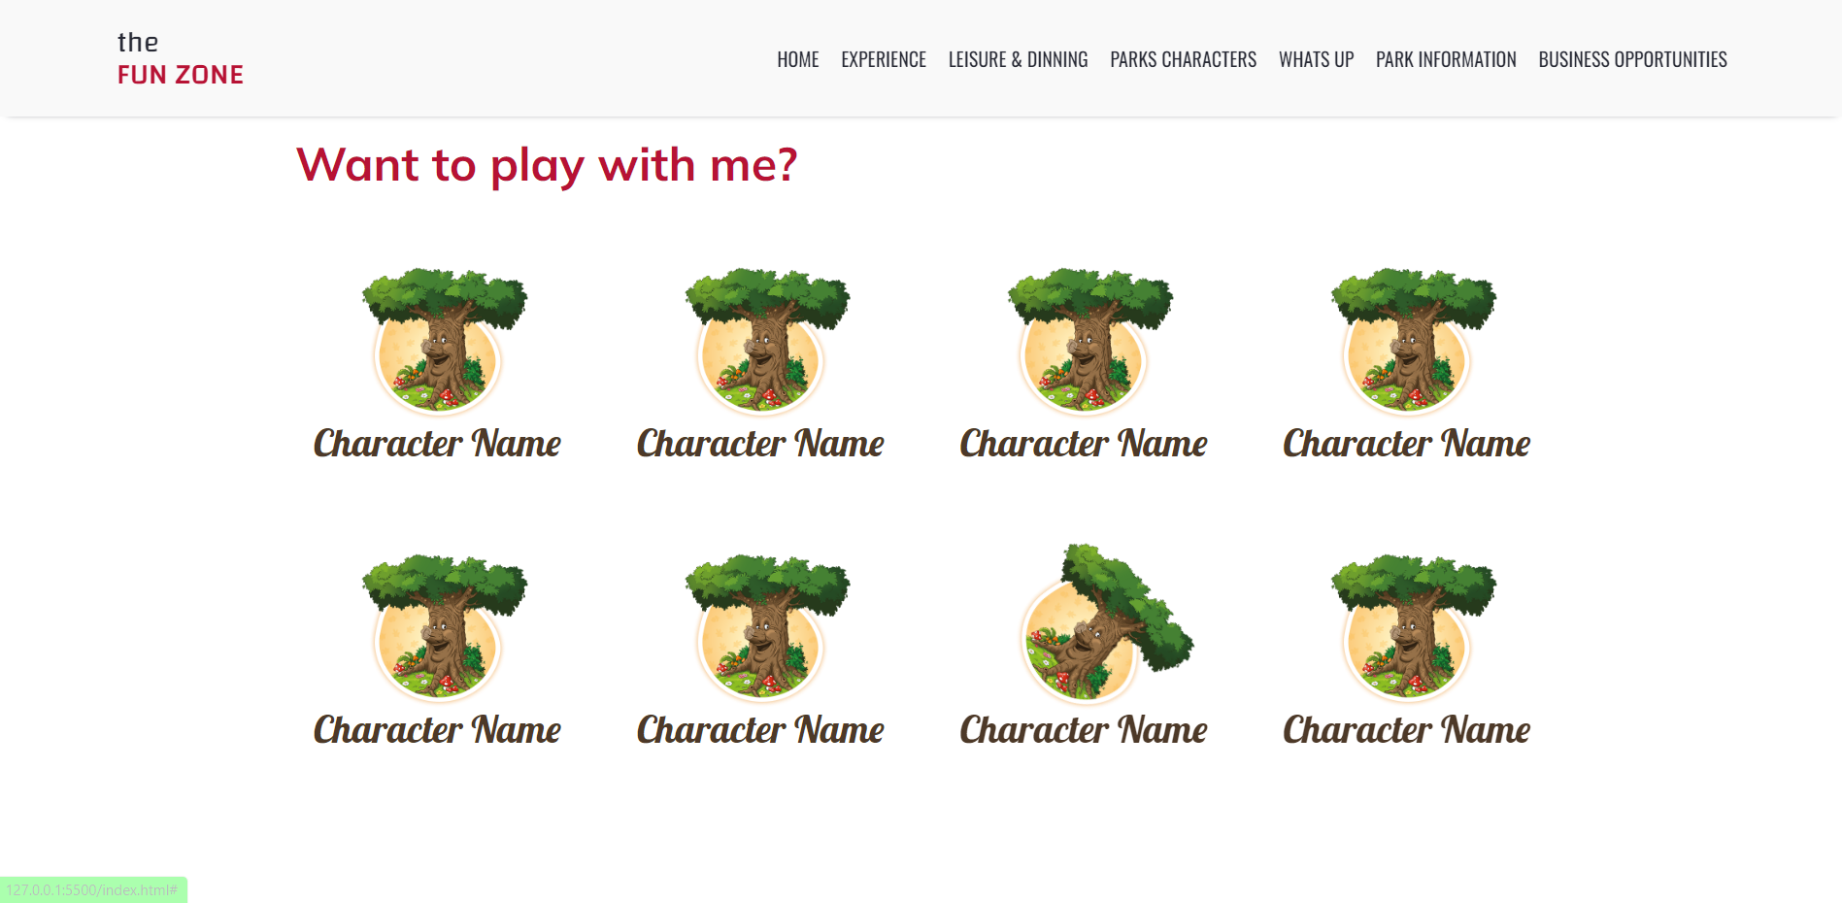

**Description:** The above part is a general introduction when entering the park what characters we will meet then below we will suggest specific characters for customers.

### Whats up.

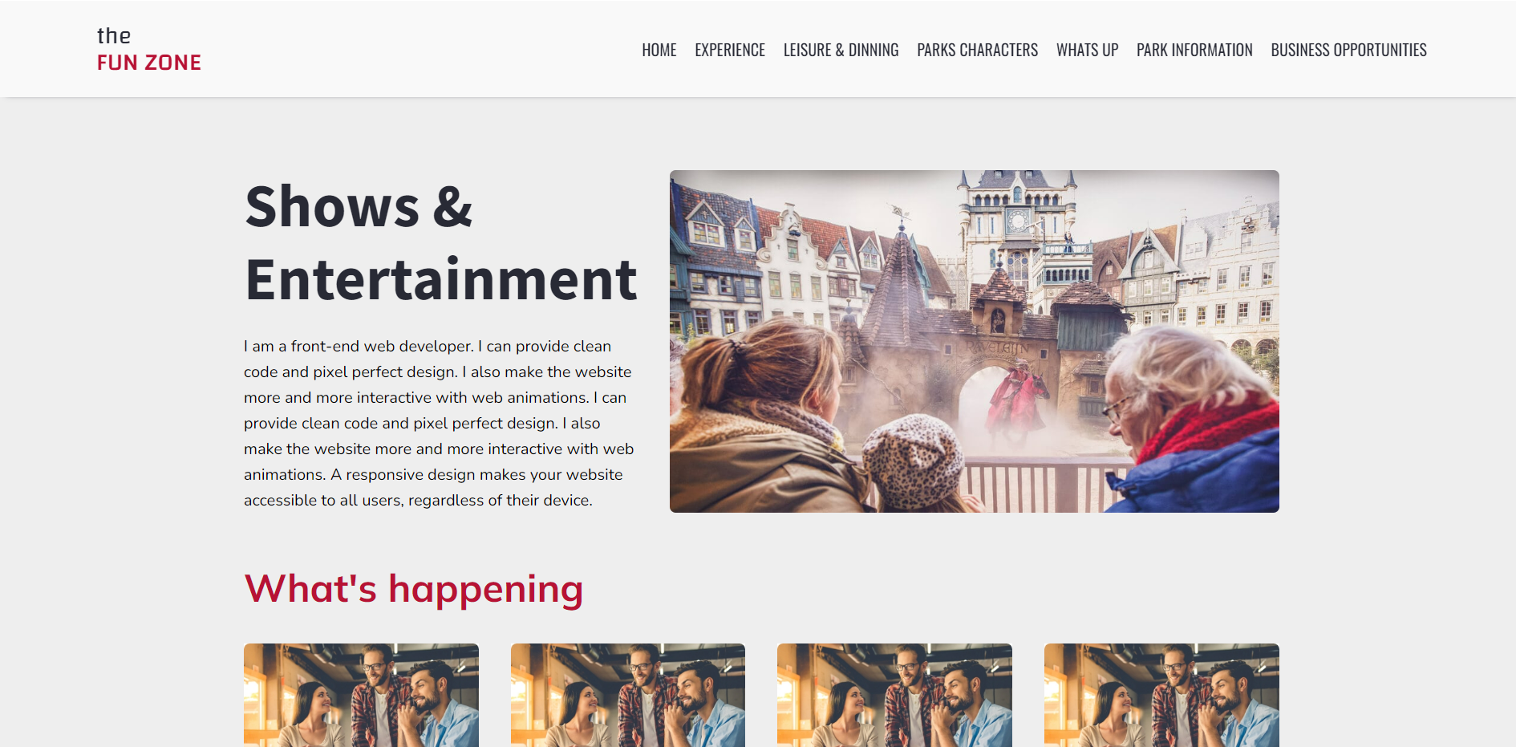 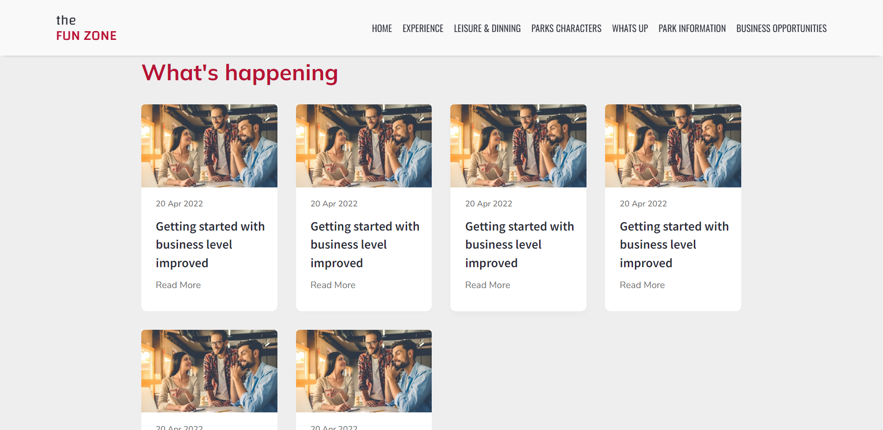

**Description:** The above section will introduce how to organize entertainment programs. Below is a series of events that have been and are coming up for users' reference.

### Park Information.

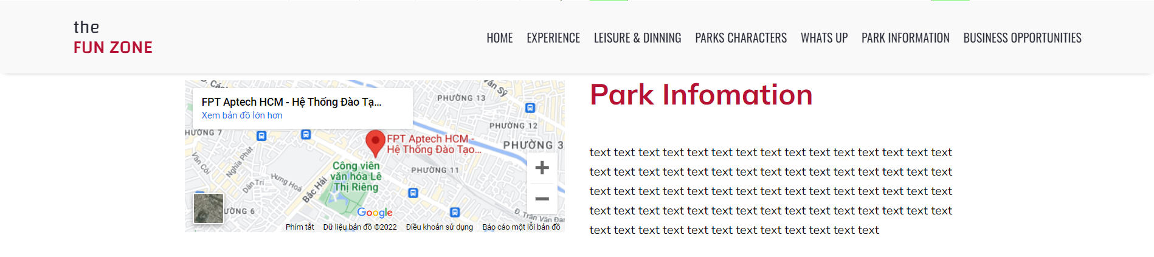

**Description:** In this section, we will give an overview of the park such as: location, date of establishment, goals, development process ... creating a sense of security for users.

### Business Opportunities.

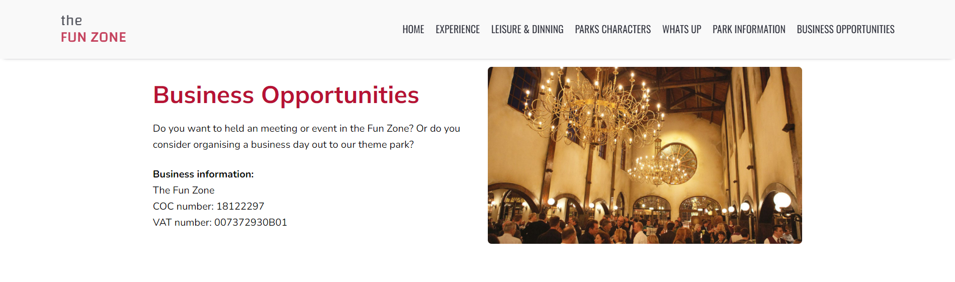

**Description:** An overview of the benefits, advantages and disadvantages when users become our partners.

### Contact Us.

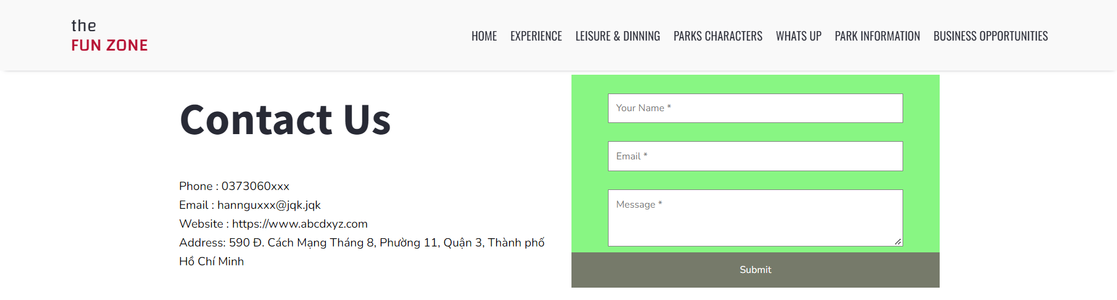

**Description** : provide users with information to easily contact us and make available a window for users to immediately send information to us on the right side.

### Footer.



**Description :** In the footer of the website, there will be a box for users to login with their email, below there will be the ap that the park links to make it easy for users to find out.

|  |  |  |  |  |  |  |
| --- | --- | --- | --- | --- | --- | --- |
| **Project Ref No.** | **Project Title – Ask Me Mobile** | **Activity Plan Prepared by** | **Date of preparation of Activity Plan** | | | |
| **Task** | **Actual Start Date** | **Actual Days** | **Teammate Names** | **Status** |
| Brainstorming ideas for layouts and Project Object | | Dương, Hân, Anh | 22/05/2022 | 1 days | Dương, Hân, Anh | Completed |
| Draw site maps and architecture design | | Hân, Anh | 22/05/2022 | 1 days | Hân, Anh | Completed |
| Wire framing general page layout | | Dương | 25/05/2022 | 3 days | Dương | Completed |
| Collect static assets (pictures, mp4, documentation,…) | | Anh , Dương | 25/05/2022 | 3 days | Anh , Dương | Completed |

# 

# REVIEW 2

WEBSITE USER INTERFACE

### Homepage

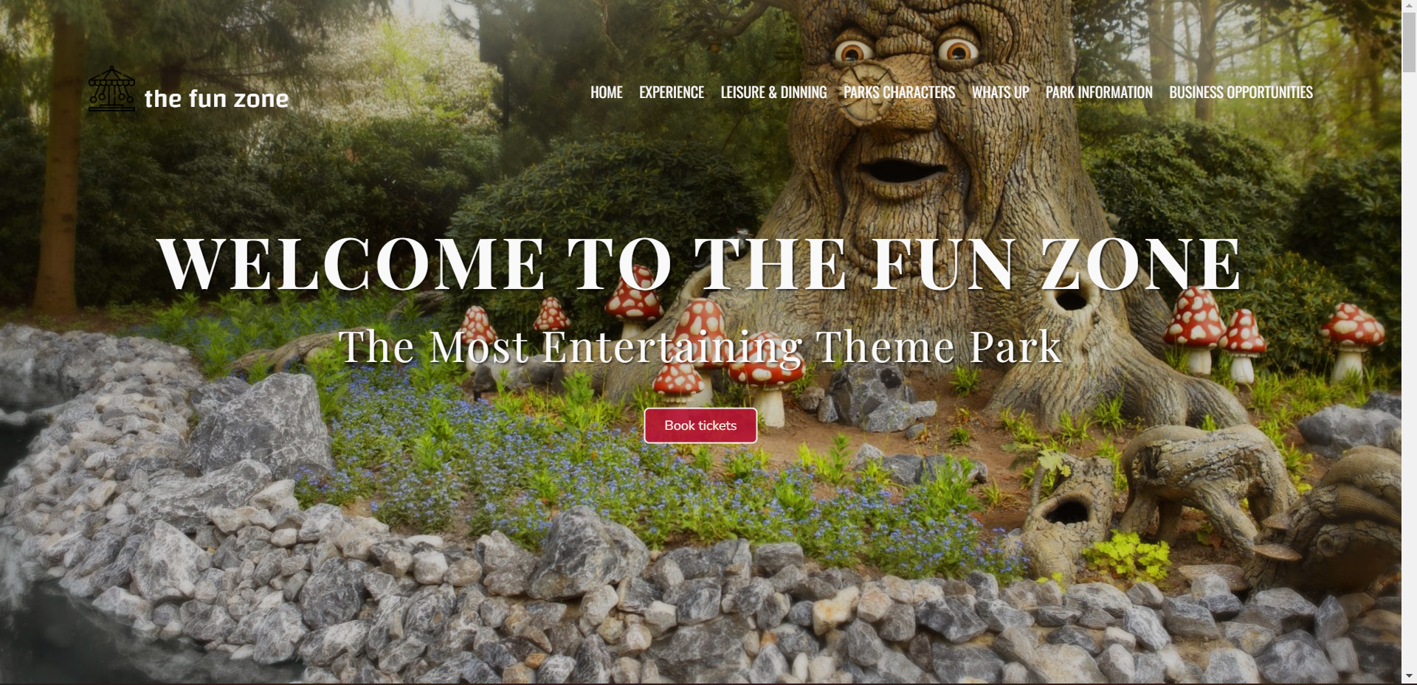

### Experience

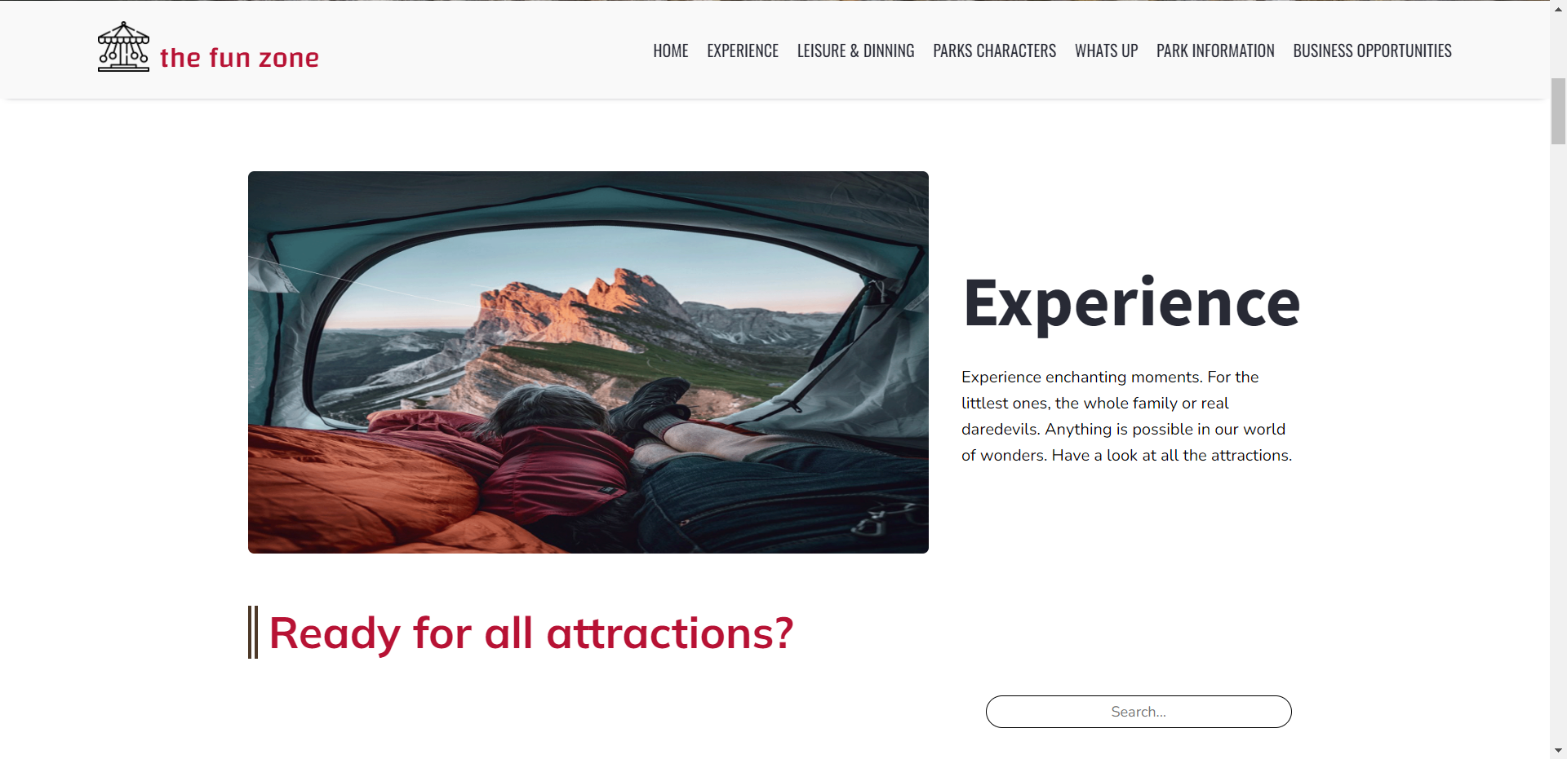

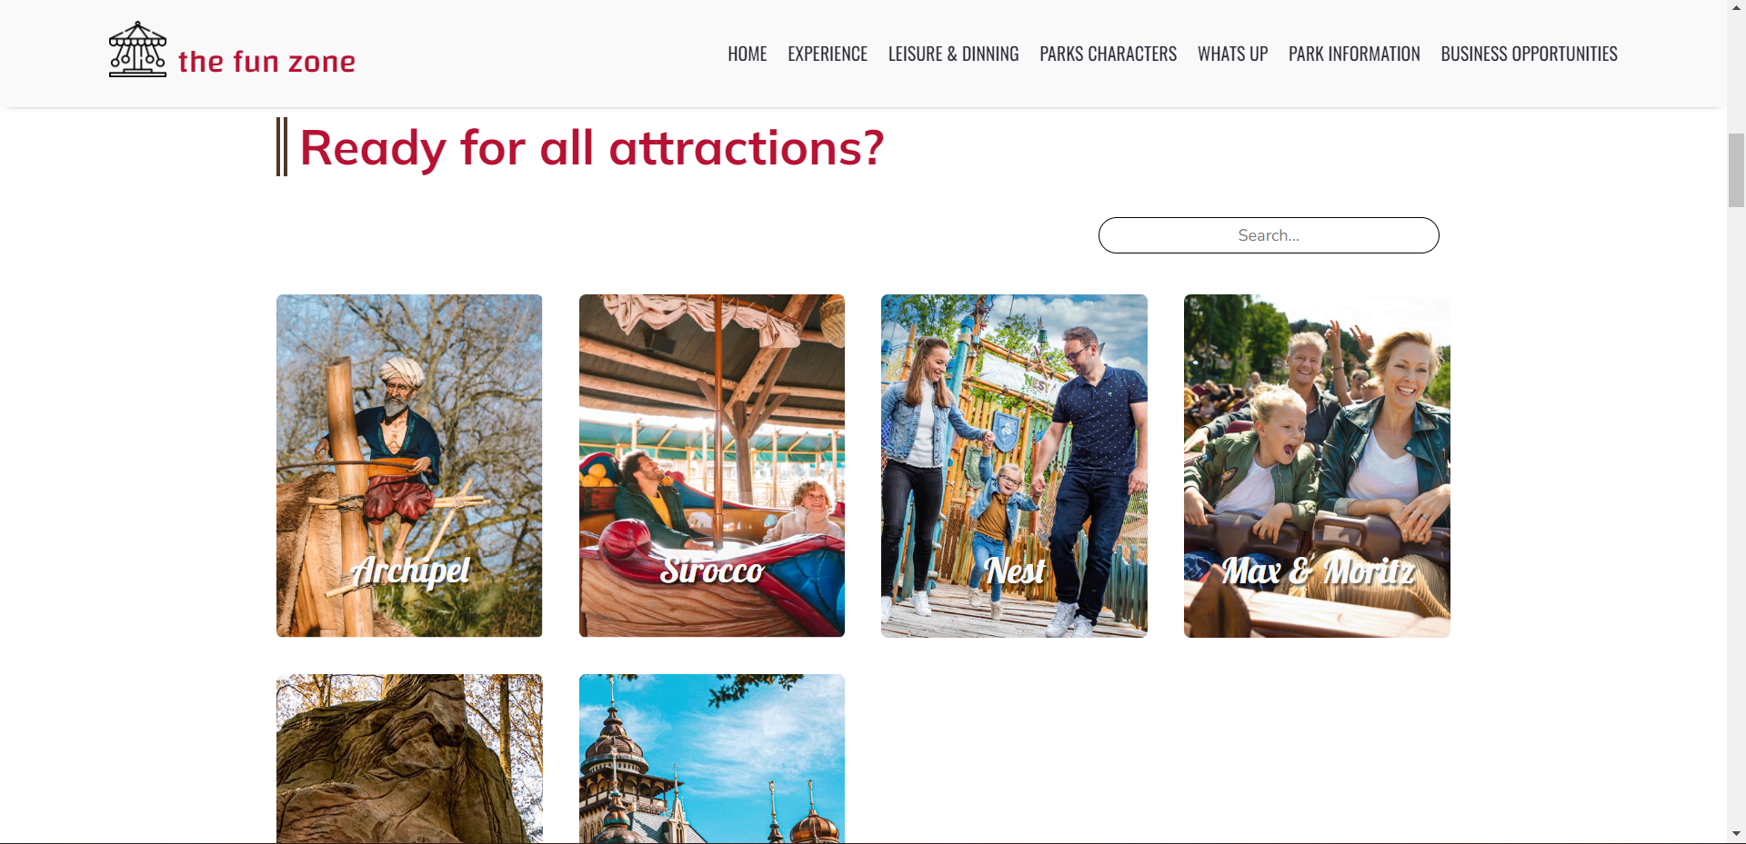

### Leisure & Dinner

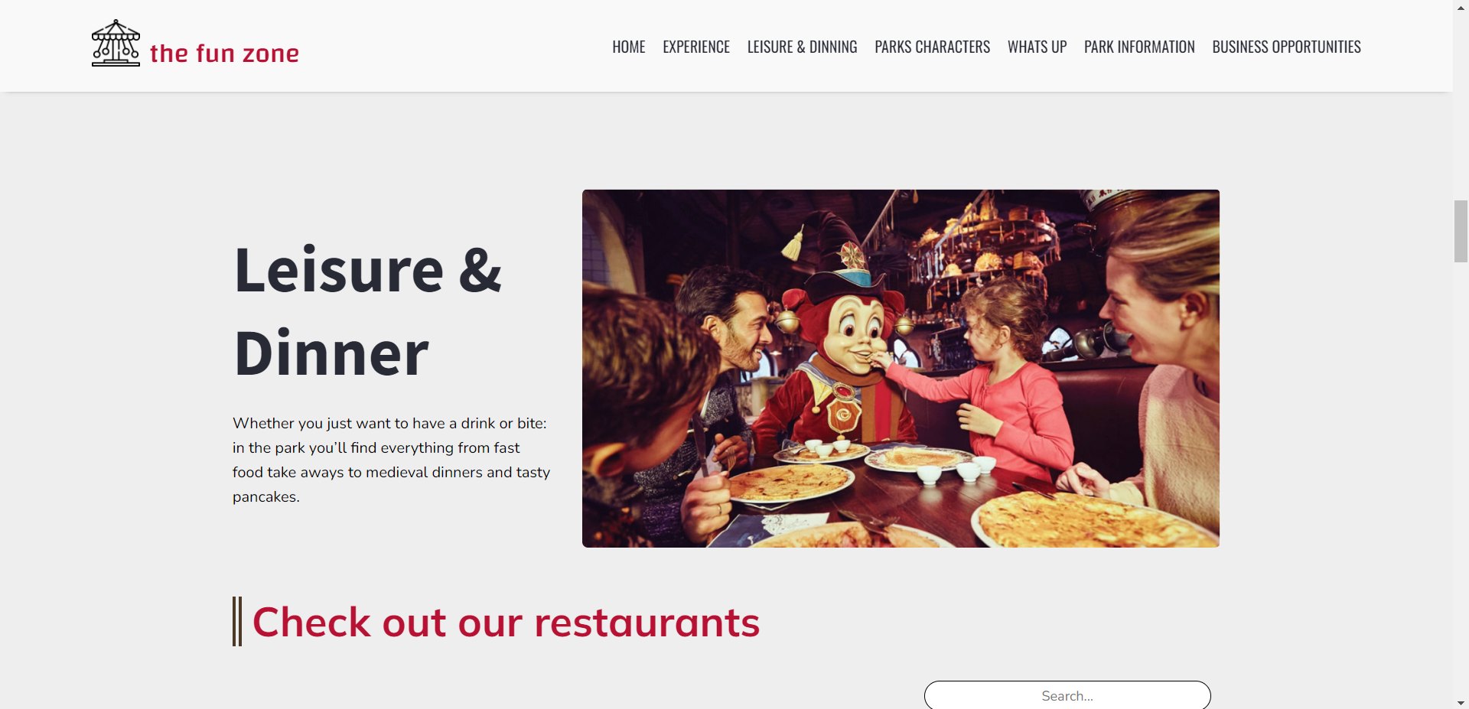

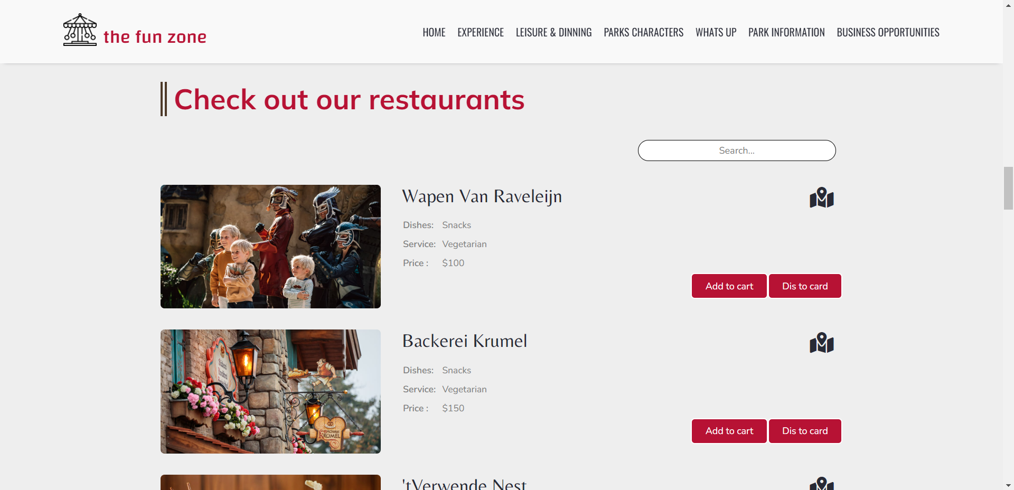

### Parks Characters

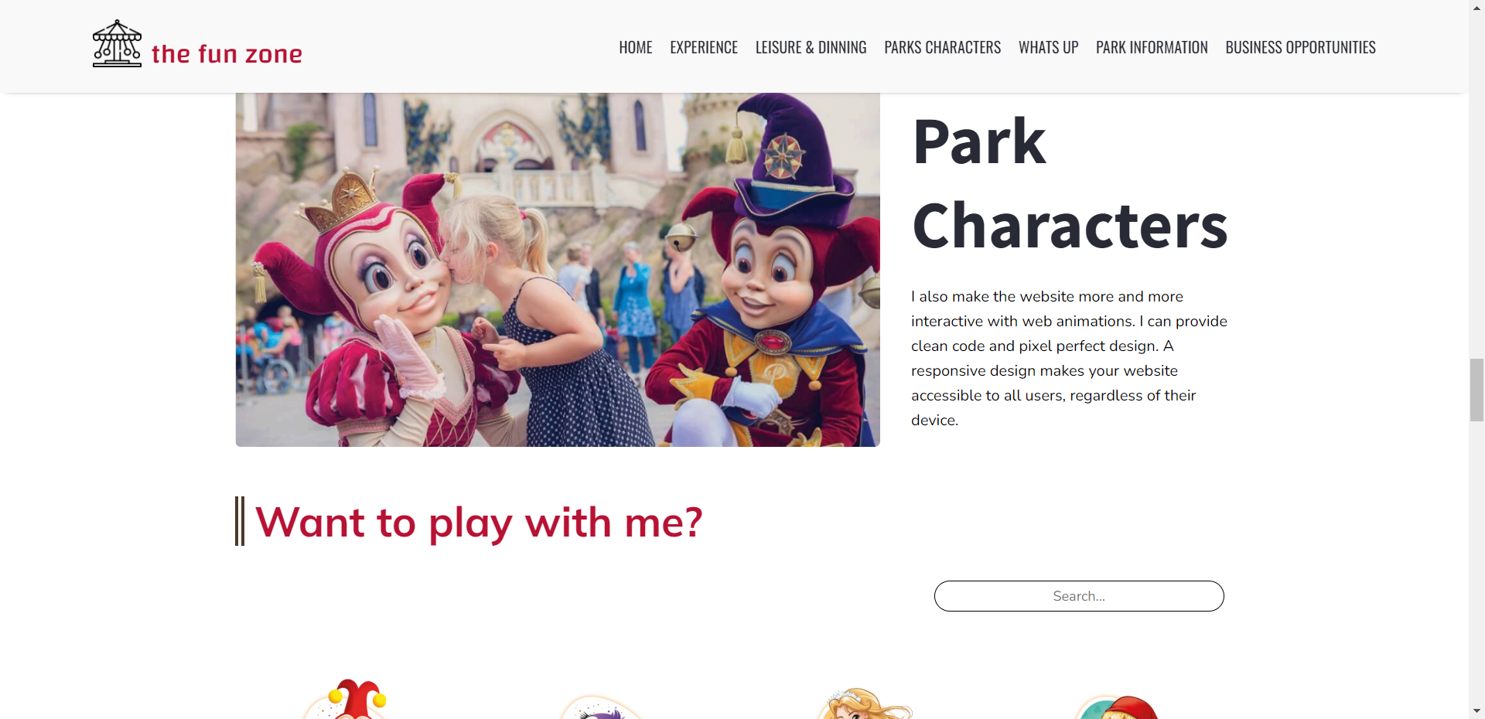

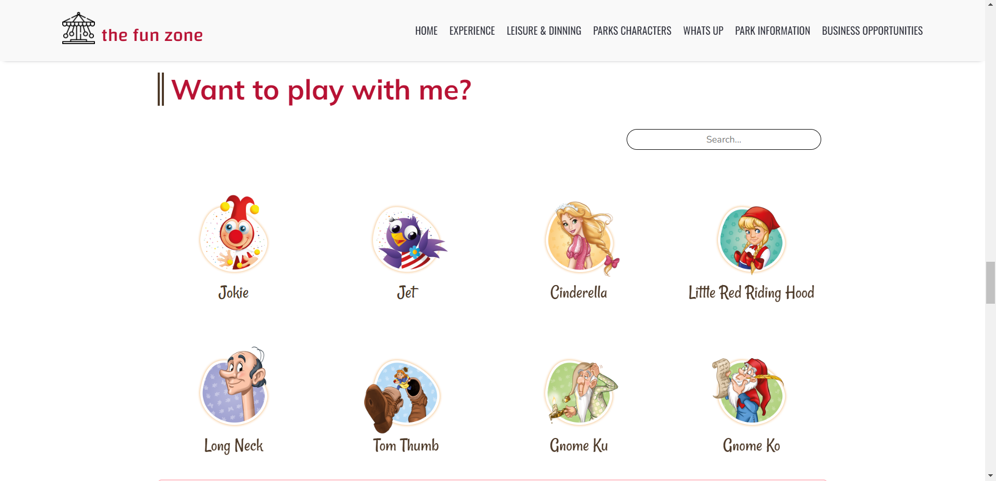

### Whats up !

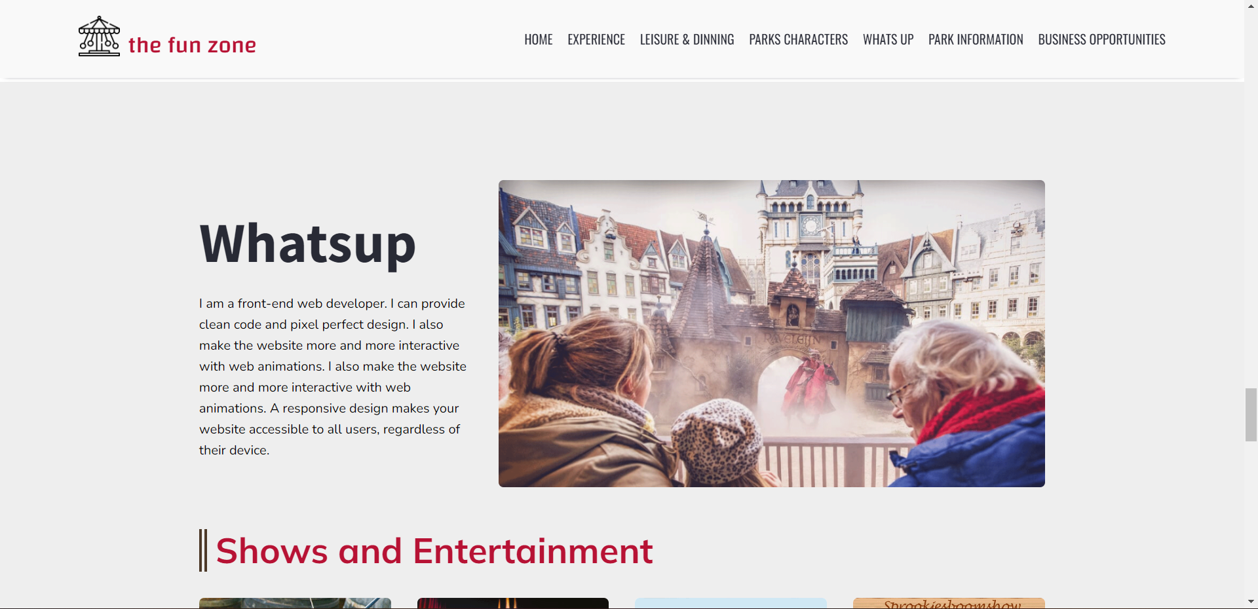

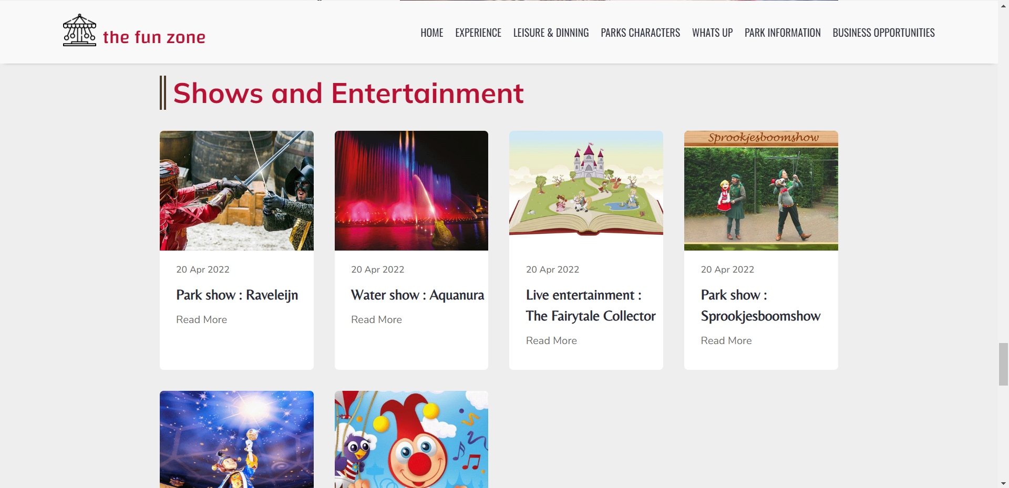

### Park Information

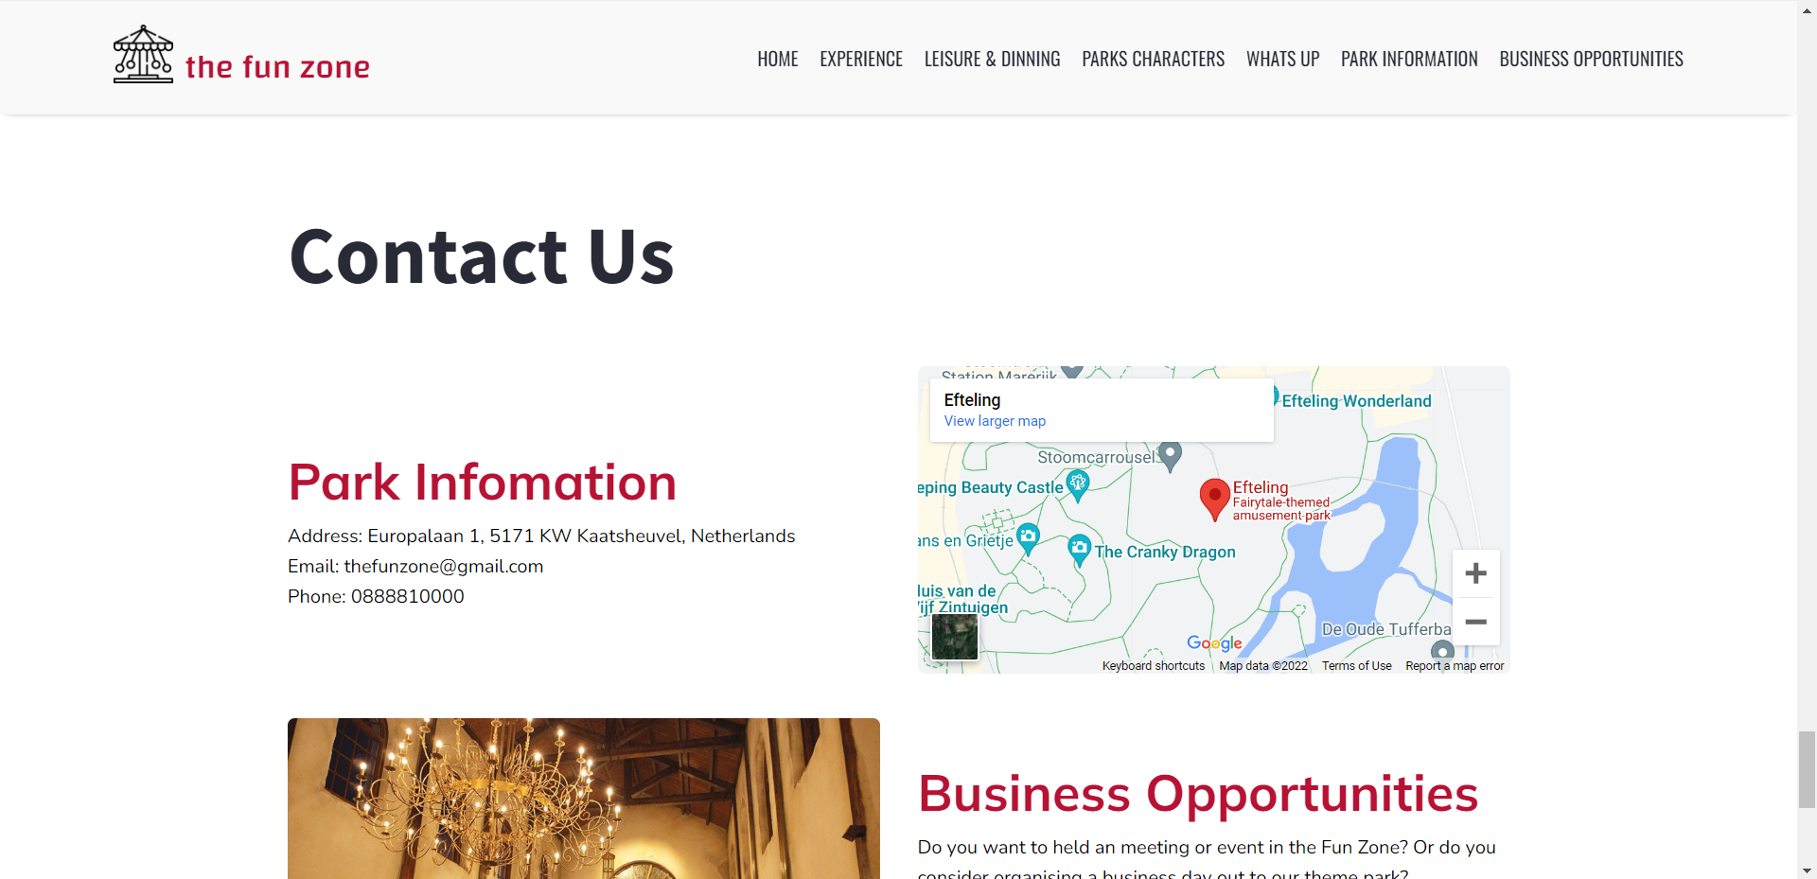

### Business Opportunities

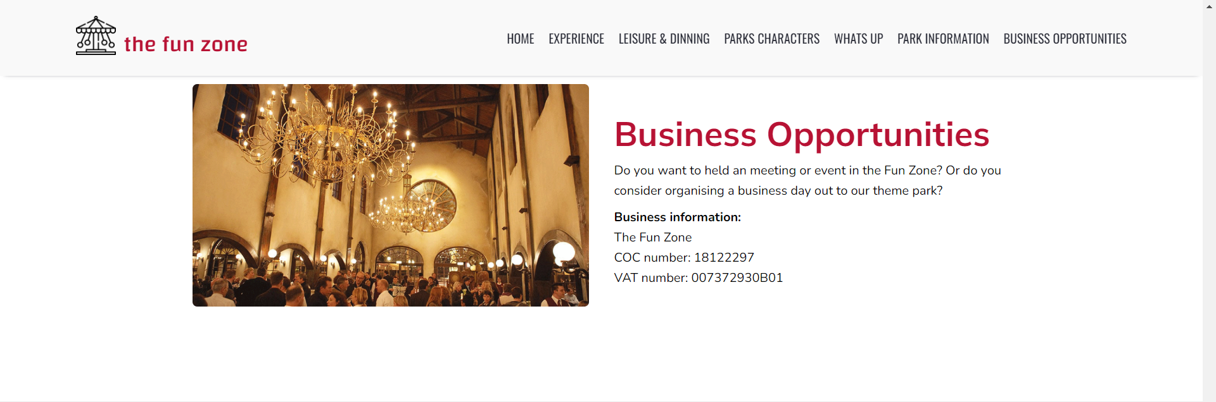

### Footer



## Task Sheet

|  |  |  |  |  |  |  |
| --- | --- | --- | --- | --- | --- | --- |
| **Project Ref No.** | **Project Title – Ask Me Mobile** | **Activity Plan Prepared by** | **Date of preparation of Activity Plan** | | | |
| **Task** | **Actual Start Date** | **Actual Days** | **Teammate Names** | **Status** |
| Brainstorming ideas for layouts and Project Object | | Hân, Anh, Dương | 18/05/2022 | 2 days | Hân, Anh, Dương | Completed |
| Draw site maps and architecture design | | Hân | 20/05/2022 | 3 days | Hân | Completed |
| Wire framing general page layout | | Dương | 24/05/2022 | 3 days | Dương | Completed |
| Collect static assets (pictures, mp4, documentation,…) | | Anh | 28/05/2022 | 3 days | Anh | Completed |
| Design & Build Homepage | | Dương | 01/06/2022 | 2 days | Dương | Completed |
| Design & Build Experience | | Dương | 03/06/2022 | 2 days | Dương | Completed |
| Design & Build Leisure & Dinning | | Dương | 05/06/2022 | 2 days | Dương | Completed |
| Design & Build Parks Character | | Hân | 07/06/2022 | 2 days | Hân | Completed |
| Design & Build What up | | Hân | 09/06/2022 | 2 days | Hân | Completed |
| Design & Build Parks Information | | Anh | 11/06/2022 | 2 days | Anh | Completed |
| Design & Build Business Opportunities | | Anh | 13/06/2022 | 2 days | Anh | Completed |
| Design & Build Footer | | Dương | 15/06/2022 | 2 days | Dương | Completed |
| Write Project Report | | Hân | 17/06/2022 | 1 days | Hân | Completed |

## Testing document

|  |  |  |  |  |
| --- | --- | --- | --- | --- |
| **Sr.No** | **Features Tested** | | | **Remarks** |
| 1 | Are all the users able to view the images and links? | | | OK |
| 2 | Have all the views, modules and controllers been | |  | OK |
| properly integrated and is the site function as a single | | |
| page application? | |  |
| 3 | Are the GUI content devoid of spelling mistakes? | | | OK |
| 4 | Is the Website launching correctly in all popular | |  | OK |
| browsers? |  |  |
| 5 | Are all the forms validated with proper criteria? | | | OK |
| 6 | Do all text links lead to the appropriate website? | | | OK |
| 7 | Do all image links lead to the appropriate website? | | | OK |
| 8 | Are all the images and links clearly visible on the page? | | | OK |
| 9 | Does the Web page work properly in all the tested | |  | OK |
| browsers? |  |  |
| 10 | Does the Web page take too long to be loaded fully? | | | OK |
| 11 | Is the navigation sequences correct through all the Web | | | OK |
| pages on the site? | |  |
| 12 | Is the JavaScript code working as expected in all click | | | OK |

## Final checklist

|  |  |  |  |  |
| --- | --- | --- | --- | --- |
| **Sr.No** | **Features Tested** | | | **Remarks** |
| 1 | Are all the users able to view the images and links? | | | OK |
| 2 | Have all the views, modules and controllers been | |  | OK |
| properly integrated and is the site function as a single | | |
| page application? | |  |
| 3 | Are the GUI content devoid of spelling mistakes? | | | OK |
| 4 | Is the Website launching correctly in all popular | |  | OK |
| browsers? |  |  |
| 5 | Are all the forms validated with proper criteria? | | | OK |
| 6 | Do all text links lead to the appropriate website? | | | OK |
| 7 | Do all image links lead to the appropriate website? | | | OK |
| 8 | Are all the images and links clearly visible on the page? | | | OK |
| 9 | Does the Web page work properly in all the tested | |  | OK |
| browsers? |  |  |
| 10 | Does the Web page take too long to be loaded fully? | | | OK |
| 11 | Is the navigation sequences correct through all the Web | | | OK |
| pages on the site? | |  |
| 12 | Is the JavaScript code working as expected in all click | | | OK |